

`

TOM Integration
Specification
Space, Range and Display Location Sequence
StoreRange to StoreLine

S093

Project BEN Code:
Author: | Evelyn Ponraj
Date: | 21/09/2007
Version: | 0.4
Status: | Draft
Modified By:
Reviewed By:

Change Record
Author | Date | Version | Change Reference, description
Evelyn Ponraj | 21/09/2007 | 0.1 | Draft
Evelyn Ponraj | 26/09/2007 | 0.2 | Updated the BATCH_OPER information.
Evelyn Ponraj | 27/09/2007 | 0.3 | The field Fixture Group ID removed from StoreLine.
Evelyn Ponraj | 10/10/2007 | 0.4 | Included the process how data is sent to StoreLine.(2.4.3)

Reviewers
Name | Position
Shajitha Mohammed | Designer
Evelyn Ponraj | Developer
John Cowper | Solution Architect
Andrew Barker | Solution Architect
Prasanth Dukaram | Development Lead

Sign-Off
By signing this form, I understand and agree with the contents of this document.
Business Owner/Customer
Position | Engagement Architect
Signature | <Physical signature or via email approval>
Date | dd/mm/yyyy (<version signed off>)

Distribution List
Name | Date of Issue | Version
Jon Braggs
Andrew Barker
John Cowper
Jim Jeffery
Shajitha Mohammed
Evelyn Ponraj
Prasanth Dukaram

Related Documents

A complete interface specification requires the documents- an Interface Specification, a Mapping spreadsheet. This section identifies these documents plus other documents as appropriate.
Mapping spreadsheet
S093- SRDLocationSequence (SR to StoreLine) Mappings 0.1.xls

Other Reference Documents
FSD9303_SEL_Content_Enhancements.doc
CRL16548_ItemLocationEnhancements (4).doc
TescoV8PLUandGeneralBatchFilesTechRef (3).doc
Commercial RTI DDS Service Instructions - Release Notes.doc

The above documents can be found in the link mentioned below.

Document Source (“docshare”)
http://docshare/UK%20IT/TOM%20Integration/Shared%20Documents/Forms/AllItems.aspx?RootFolder=%2fUK%20IT%2fTOM%20Integration%2fShared%20Documents%2f1%20%2d%20Design%2fInterface%20Design%20Documents%2fSpace%20Range%20and%20Display%20%28SRD%29%20Interfaces%20%28S%2dPrefix%29%2fS093%20%2d%20Product%20Location%20Sequence%20from%20Store%20range%20to%20Storeline&View=%7bDFD57AEE%2d4D2D%2d4A52%2d8E91%2dA19AEFB34619%7d
Table of Contents
1 Introduction 5
1.1 Purpose of Document 5
1.2 Background 5
1.3 Scope 5
2 Description and Requirements for the Interface 6
2.1 Scope 6
2.2 Detailed description of the end-to-end interface 6
2.3 Logical Schematic (physical location of components may differ) 7
2.4 Components in the End-to-End Interface 7
2.4.1 Data read 7
2.4.2 Data transformation 8
2.4.3 Data load 8
3 Source / Target Definitions 8
3.1 Source Message Details: 8
3.2 Source Technical Details 9
3.3 Target Message Details: 9
3.4 Target Technical Details 12
4 Non-Functional Requirements 13
5 Assumptions and Outstanding Issues 14
5.1 Assumptions 14
5.2 Outstanding Issues 14

Introduction

Purpose of Document
The purpose of this document is to describe the interfacing requirements w.r.t SRD product position data to be downloaded to StoreLine from Store Range. This will enable the printing of shelf edge labels in a sequence.
The document is of a sufficiently technical nature to allow a developer to build an actual interface. Additionally the document contains detail that might sit logically within a Technical System Design (TSD) document, but is contained here for expediency. There is therefore no associated TSD for this interface.

Interface S093 is currently required in US and is expected in Turkey when the store is completely planogrammed.

Background
SRD manages a group of attributes which are required either to appear on Storeline shelf-edge-labels (SELs) or to be used by Storeline in its processes to produce the SELs.
In the USA Fresh and Easy stores will be fully ‘planogrammed’ from day one; and the possibility exists that product position data can be downloaded to StoreLine so as to enable the printing of shelf-edge-labels in a sequence more sympathetic with the chores of the Price Integrity Team than previously possible.
StoreLine provides an interface for the batch download of product position (or in StoreLine terms, “Locations”). Such a batch file allows the centre to download, for each product position an item number up to 10 position parameters. Each of these is a 20-byte alphanumeric field. The significance of these parameters is that: (a) together they identify a single, precise position; and (b) it’s possible to print a batch of labels in product position sequence. This interface also allows a product to have many positions.
In order to achieve an efficient label print sequence four of StoreLine’s position parameters will be used. These will be, in order, Planogram Start ID Module Number, Relative Module Number, Shelf ID and Position on shelf.
With this information being available to StoreLine it will be able to print the correct number of labels when changes to product data necessitate new labels and Shelf-edge labels can be printed in a sequence that will facilitate a quicker, more efficient, less expensive manner, with fewer errors likely and thereby not missing out on the benefits of planogramming the entire Store.

This document describes the product position general batch files to be sent to StoreLine.

Scope
The Interface Specification covers:

- audit requirements across the interface
- security requirements across the interface
- timing/frequency requirements or constraints
- support requirements
- archiving
- the data format to be used for the interface at each stage (e.g. xml messages)
- the normal processing required at each stage
- recovery from failure required at each stage
- volumes.

Note that it is Tesco strategy to avoid placing any business logic in integration layer processing.

Description and Requirements for the Interface

Scope
StoreRange in SRD will contain the product position information which needs to be sent to Storeline. S093 is responsible for extracting the product position from Location Sequence file (SR93) and send the full update of location sequence to StoreLine.
As part of a scheduled run, this interface will read the flat file and reformat to the General Batch file layout, and send one file per store to the relevant instance of Storeline. Initially the file is set to run as ‘one- off’ and then a weekly job would run for the full upload of data when the BTCH_OPER value in the output file is set to 82.
On successful completion, the source data will be marked as processed by S093, preventing reprocessing on next execution.

Detailed description of the end-to-end interface
S093 will be executed by CA Autosys.
S093 will pick SR93 Location Sequence file from StoreRange The data is transformed according to the mapping spreadsheet (see “Related Documents” section), before being output into one file per store, and the full update of location sequence is sent to StoreLine as a general batch extract. The field BTCH_OPER in the output file is set to a value will be used to denote whether a file refresh is required. The possible values of this field are 0 (manual execution), 1 (execute on specified date) and 82 (full re-build).StoreLine requires this field to be set to 82 for full upload. The set of files are temporarily landed to a configurable location on the IL and finally, a separate component will pick up the temporary files from the IL server shared area, identify which particular Storeline instance is relevant for the storeID in the filename, renames the file as appropriate, transmits to the physical target location of that Storeline instance, and archives (TBC) the IL temporary file to a archive folder.

Logical Schematic (physical location of components may differ)
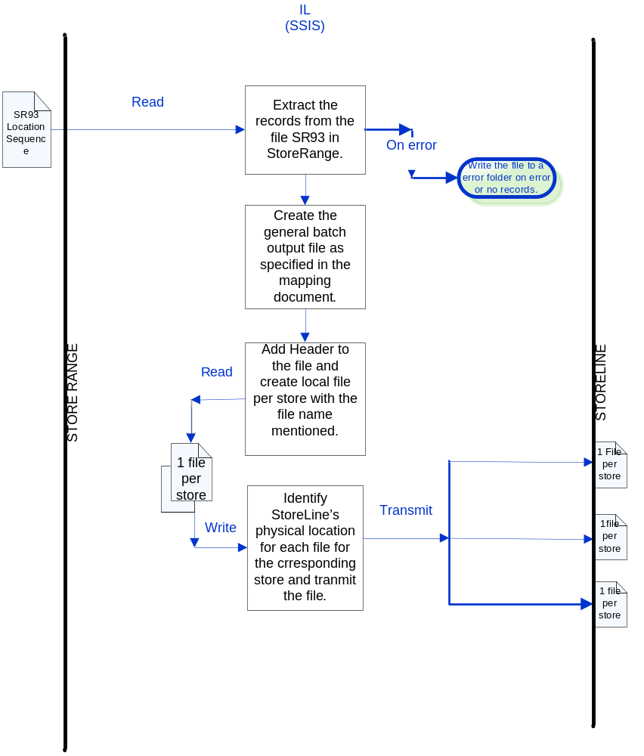

Components in the End-to-End Interface
SSIS
Package Name: TOM.S093.SRtoStoreline.LocationSequence.dtsx
SSIS Procedure
Name | TOM.S093.SRtoStoreline.LocationSequence.
IDS Stored Procedure
Name | GetIPAddress.  GetBatchNumberSSIS.
SSIS / BTS Sub-component
Name | RTI DDS- component to transmit files to Storeline instances.

Data read
The SSIS component S093 is executed by Autosys. The facility for a ‘full file load’ (or file rebuild) will be specified in which all existing records in the PLU_Locations table are deleted and replaced by new records from the newly imported general batch file. Within the File Header record structure the field BTCH_OPER will be used to indicate whether a full file rebuild is to be performed or not. If the value of this field is set to 82 then a full file rebuild will be performed and the full update of location sequence is sent to StoreLine as a general batch extract.

Data transformation
The data is transformed in standard SSIS components as required. Mapping is provided in the document listed in the “Related Documents” section.

Data load
Files generated for relevant stores from Store Range are first placed in a temporary folder in IL, in the format required by StoreLine(detailed in mapping document), with a filename.
A final subcomponent picks up the files, identifies the target location based on the storeID, and transmits to the particular instance of storeline.
The RTI DDS is a custom component called in the SSIS package which picks up the individual files from IL, and places it in the RTI DDS queue. The Queue name or Service name in RTI DDS can be either ‘Commercial 1’, ‘Commercial 2’, ‘Commercial 3’ or ‘SSIS’ each of which is an instruction and it is configurable. (Any one of these instructions can be used).
The IP address for a particular store is present in the table dbo.StoreIPAddress which is located in the database TOMControlsAndParameters. The IP address is referenced by calling a stored procedure in the SSIS package and passed to the RTI DDS component as a variable which will have the value of the IPAddress for a particular store. The URL of the StoreLine Folder that should receive the file is also passed to the RTI DDS component through a variable using the Context Property.
There is a RTI unhosted instruction in the StoreLine server by name “Receive DDS Push Transmissions” which is configured to pick the files arriving at RTI DDS queue in the IL server. The service pulse in the RTI administrator of StoreLine is configured to point to the IL server (location of the package). The files are then picked based on the IPAddress.

Source / Target Definitions

Source Message Details:
The data for this interface is sourced from the file SR93 Location Sequence in StoreRange.
The Full Update of Location Sequence is send to Storeline.

Source file Name: SR93 Location Sequence (SR to Storeline).
Outbound →
Field | Description | Format
Header Record |  | Len 61
HeaderRECTYPE | Value ‘0’ | Char(1)
RUNDATE | YYYY-MM-DD | Char(10)
RUNTIME | HHMMSS | Char(6)
FILLER |  | Char(44)
Detail Record |  | Len 61
DetailRECTYPE | Value ‘1’ | Char(1)
Store Number |  | Integer(5)
Product |  | Integer(9)
Planogram ref |  | Char(16)
Display Group |  | Char(5)
Mod Sequence |  | Integer(5)
Shelf number |  | Integer(5)
Product position |  | Integer(5)
Start Mod number |  | Char(10)
Trailer Record |  | Len 61
TrailerRECTYPE | Value ‘9’ | Char(1)
RECCOUNT |  | Integer(9)
FILLER |  | Char(51)

Source Technical Details

Feature | Specification | Additional Information
Source System Name | StoreRange
Source Platform / OS | Windows 2003 Server
Source Physical Location | \\<SR Server>\OUTBOX (File Share)
Source Underlying Data Storage Technology | RDBMS
Transfer Function | HTTP (Put/Post) □  HTTPS (Put/Post) □  Message Queue □  FTP □  File Drop(Windows) □  (XCOM) □  SSIS ☑
Data Format. | XML □  Delimited □  Positional ☑  RDBMS □
Decryption/Encryption | No
Decompression/Compression | No
Transmission Mode | Synchronous ☑  Asynchronous □  Bulk Data ☑
Real-time/Scheduled Batch | Scheduled Batch
Archiving | The file should be moved to the Archive folder in IL
Logging | Log via the Operational Framework.
Error Handling | Processing should prevent sending of duplicate messages, unless this occurs during recovery from failure.

Target Message Details:
The general batch format for PLU-Locations will be used to import item location data into the Storeline database. A description of the General Batch process and the associated file formats are given in the document Tesco V8 PLU and General Batch Files Tech Ref.doc.
The format of PLU-Locations GB is shown below. It is comprised of the following
- A file header record
- Multiple detail records made up of
- A record header
- Record details

File Header Record:
File Header Record Fields | Data | Type & Size | Comments
Header indicator | 999 | ASC_N (3) | Always 999
Automatic Execution Date | YYMMDD | ASC_DT (6) | Date & time when batch is scheduled to run in store
Automatic Execution Time | HHMM | ASC_N (4) | Date & time when batch is scheduled to run in store
Batch Number |  | ASC_0 (6) | Sequential number to be allocated by system creating the GBs
Description |  | ASCII (20) | Batch description
Flags | 00000000 | ASC_N (8) | Not in use
Next Batch to Run | 000000000 | ASC_N (9) | Not applicable
Run Mode | 000 | ASC_N (3) | Not applicable
EXEC_GRP_NBR | 000000 | ASC_N (6) | Not applicable
BTCH_OPER |  | ASC_N (3) | 003 - for immediate execution. 82- for full upload.(To be made configurable)
Filler |  | ASC_0 (956)
Total Bytes |  | 1024

Record Header
Record Header Fields | Data | Type & Size | Comments
File type | 150 | ASC_N (3) | 150 for Locations
Action | 005 or 006 or 008 | ASC_N (3) | 5 Insert  6 Update  8 Delete
Filler |  | ASC_0 (58)
Total Bytes |  | 64

Detail Records
Field | Description | Type | Size |  | Offset | Validations
Record Header |  |  | 64 |  |  | See record header format above
Entity |  | ASC_N | 1 | 65 |  | 0 – PLU  1 – Internal number  (Identifies item type)
Item |  | ASC_N | 14 | 66 |  | 0–99999999999999
Location ID |  | ASC_N | 2 | 80 |  | If empty, Storeline will create the sequential numbers
Location param id (1) | Mod Number | ASCII | 20 | 82
Location param id (2) | Relative Mod Number | ASCII | 20 | 102
Location param id (3) | Shelf ID | ASCII | 20 | 122
Location param id (4) | Position Number | ASCII | 20 | 142
Location param id (5) |  | ASCII | 20 | 162
Location param id (6) |  | ASCII | 20 | 182
Location param id (7) |  | ASCII | 20 | 202
Location param id (8) |  | ASCII | 20 | 222
Location param id (9) |  | ASCII | 20 | 242
Location param id (10) |  | ASCII | 20 | 262
Filler |  |  | 743 | 282
Total |  |  | 1024

The file name is of the format BXTTTNNNNNN.DAT
Where
BX – general batch prefix
TTT – file type (= 150 for Locations)
NNNNNN – batch number

Example – BX150000003.dat
This file is landed in the IL server so that a final transmission component can manage the transfer of each created file to the required physical Storeline instance location.

A short description of the fields:

- File Header
The field BTCH_OPER will be used to denote whether a file refresh is required. The possible values of this field are 0 (manual execution), 1 (execute on specified date) and 82 (full re-build).

- Record Header
For Action field the value may be specified as 10. This option is only relevant to batch type 150 –PLU_Locations. This action performs a ‘selective deletion’ – when this action value is specified for a particular item in the general batch, then all records on the PLU_LOCATIONS table which have the same first location element as the item in the general batch will be deleted.

- Detail Record
The ‘Entity’ is used to identify the item type i.e. 0 – PLU, 1 – Internal number.
The ‘Entity’ must be the same for all items within the same batch.
If the Entity is specified as 1 (internal number), then the system updates the locations for all PLUs linked to the internal number.

Field | Set to | Comment
Record Type | “150” | 150 indicates a change to the location data
Action | “005” or “008” | 005 is the code for an insert; and 008 is the code for a delete, which removes one of the item’s positions (as opposed to all of them).
Entity | “1” | 1 indicates that the field below contains, in StoreLine Terms, “an Internal Product Number”, but which in Tesco terms is a level 2 item code.
Item | Item Code | This field identifies the level 2 code of the item that may be found at the position indicated by the position parameters below.
Loc. Param. 1 | Module No. | This identifies module number within the fixture group onto which the leftmost module of the planogram (containing the above product) has been mapped.
Loc. Param. 2 | Relative Mod. No. | This identifies the module within the planogram where the above product has been positioned. This number should be formatted as a five-digit number with leading zeroes.
Loc. Param. 3 | Shelf ID | This identifies the shelf within the module where the above product is positioned. This number should be transformed in such a manner as to reverse the direction. The shelf numbers provided by SRD will be numeric, starting at 1 for the lowest shelf and rising as we progress up the planogram. The number sent to StoreLine should be calculated as 10000 less the number provided by SRD, and formatted as a five-digit number with leading zeroes
Loc. Param. 4 | Shelf Position | This identifies the position on the shelf where the product is positioned. This number should be formatted as a five-digit number with leading zeroes.

Target Technical Details
For messages destined for Storeline (via a temporary landing on the IL server):

Feature | Specification | Additional Information
Target System Name | Storeline
Target Platform / OS | Windows 2003
Target Physical Location | C:\Program Files\StoreLine\Office\Import
Target Underlying Data Storage Technology | SQL Server 2005
Transfer Function | HTTP (Put/Post □  HTTPS (Put/Post) □  Message Queue □  FTP □  File Drop (Windows) □  (XCOM) □  RTI File Adapter ☑  SSIS □ | To be determined.
Data Format | XML □  Delimited □  Positional ☑  RDBMS □
Decryption/Encryption | No
Decompression/Compression | No
Transmission Mode | Synchronous □  Asynchronous ☑  Bulk Data □
Real-time/Scheduled Batch | Scheduled – runs after completion of transformation.
Archiving | N/A
Logging | Log via the Operational Framework.
Error Handling | tbd

Non-Functional Requirements
Audit Requirements | The interface will use the components provided by the Operational Framework to satisfy audit requirements.
Security Requirements | The interface executes within a secure private domain. There is no additional security considerations required.
Performance Requirements | Not known at this stage.
Reliability and Availability Requirements | Not known at this stage.
Scalability Requirements | No Scalability requirement. The requirement is to deliver a single extract. It is anticipated that the volume of data transferred will continue to remain within the capability provided by this implementation.
Operational Support Requirements | The successful delivery, failure in the creation of the extract, and failure in message transport, must be recorded by the Integration Management Operational Framework (IMOF). In the event of failure, an alert should be raised.
Likelihood of Change Requirements | Not known at this stage.
Cultural/Global Consideration Requirements | Although multi-byte character set support is not required for US or Turkey, the interface will support multi-byte character sets through integration.
Legal Requirements | N/A
Compliance To Standards Requirements | No compliance exceptions.

The interface will make use of the audit and traceability components that are being developed as part of the Operational Framework stream. These components will be pluggable, and will be useable from BizTalk, RTI and SSIS. At the time of writing (2007-09-21) the components are in design. Developers should put a ‘placeholder’ in their code / configurations as appropriate, and meantime handle errors and exceptions as per the already delivered SRD integration components.

Assumptions and Outstanding Issues

Assumptions
ID | Assumptions
1 | As the location element fields are alphanumeric, leading spaces or zeroes will be included in the general batch to match the required element size and the correct number of characters per location will be sent to SL
2 | The field ‘ENTITY’ is set to 1 which indicates that the field below contains, in StoreLine Terms, “an Internal Product Number”, but which in Tesco terms is a level 2 item code.  If the internal number is used in the interface file, all associated PLUs will be updated with the same location.

Outstanding Issues
ID | Issue | To be addressed by

